|  |  |
| --- | --- |
| **Orienteering**  **Measuring Heights** | C:\Users\james\OneDrive\BSA\Woodbadge\Project\EEE Flag Color.JPG |

**Equipment:**

* 1 stick
* 1 friend

**The Felling Method**

The Felling Method is a way to measure the height of something, like a tree, without cutting it down. You must have access to the base of the object to do this method. To begin hold a stick out in front of you and step back from the object, make sure the top of the stick lines up with the top of the object. Then turn the stick 90 degrees to mimic the object falling. Have your friend stand where the tip of the stick lands. Pace from the base of the object to your friend to get the height of the object.

**The Stick/Pencil Method**

The Stick/Pencil Method is different from the Stick Method used for widths. With the Stick/Pencil Method have your friend stand next to the object you want to measure. You must know the height of your friend for this method to work. Hold a stick out at arm’s length and line it up so that the stick is the same length as your friend. From here move the stick up the length of the object counting how many times you move the stick up to get to the top. Finally, multiply the number of times you moved the stick up by the height of your friend. This will give you the height of the object.

**The Stick/Pencil Method**

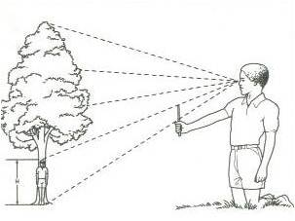

**The Felling Method**

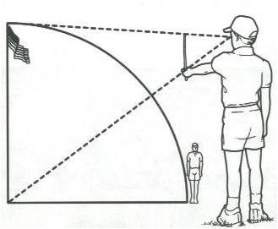

**Object:** Teach how to measure the height of an object in nature when a measuring tape will not work.